
ITM(SLS) BARODA UNIVERSITY, VADODARA
School of Computer Science, Engineering and Technology Semester - 1
Course Name : Web Technologies
Course Code : C2111C3

Problem Statement : Creating a school Bookstore survey website.

HTML CODE :
<!DOCTYPE html>
<html lang="en">
<head>
<meta charset="UTF-8">
<meta name="viewport" content="width=device-width, initial-scale=1.0">
<title>Student Bookstore Survey</title>
<style>
h1 {
font-family: Georgia, 'Times New Roman', Times, serif;
}
body {
background-color: rgba(255, 239, 190, 0.484);
}
h2 {
border-bottom: 3px solid black;
font-family: Arial, Helvetica, sans-serif;
}
div {
background-color: white;
width: 700px;
padding: 25px;
margin: auto;
}
input[type="submit"] {
background-color: rgb(159, 96, 32);
color: white;
border: none;
border-radius: 15px;
padding: 15px;
display: block;
margin: auto;
width: 120px;

}
input[type="reset"] {
background-color: rgb(159, 96, 32);
color: white;
border: none;
border-radius: 15px;
padding: 10px;
display: block;
margin: auto;
width: 100px;
}
.foot {
font-size: large;
font-family: sans-serif;

}
.endtext {
color: darkgrey;
}
</style>
</head>
<body>
<div class="container">
<h1 style="text-align: center;">Student Bookstore Survey!</h1>
<h2 style="text-align: center;">Student Info. FORM</h2>
<form>
<fieldset>
Name:
<input type="text" placeholder="Type in your name" required>
<br><br>
City :
<input type="text" placeholder="Enter your city" required>
<br><br>
Email :
<input type="email" placeholder="example@email.com" required>
<br><br>
Phone Number :
<input type="tel" placeholder="Enter your Number" required>
<br><br>
Address :
<br>
<textarea rows="4" cols="40"></textarea>

</fieldset>
<h2 style="text-align: center;">Survey</h2>
<fieldset>
How often do you purchase books?
<br><br>
<input type="radio" name="often" value="rarely">Rarely
<br><br>
<input type="radio" name="often" value="occasionaly">Occasionaly
<br><br>
<input type="radio" name="often" value="frequently">Frequently
<br><br>
</fieldset><br>
<fieldset>
Where do you usually purchase Bookstores?
<br><br>
<input type="checkbox" name="store" value="online">Online Bookstore<br><br>
<input type="checkbox" name="store" value="offline">Offline Bookstore<br><br>
<input type="checkbox" name="store" value="college">College bookstore<br><br>
Other :<br>
<input type="text" placeholder="Other Bookstore">
</fieldset>
<br>
<fieldset>
Which books do you think changed your life?
<input type="text" placeholder="Book name" required> <br><br>
What are the books that you would recommend to a Beginner?
<input type="text" placeholder="Book name" required><br><br>
Which Book you like the most to read during your free time?
<input type="text" placeholder="Book name" required>

</fieldset><br>

<fieldset>
How much usually you spend on books per month?<br><br>
<input type="radio" name="price" value="100-500">₹100-₹500
<br><br>
<input type="radio" name="price" value="500-1000">₹500-₹1000
<br><br>
<input type="radio" name="price" value="1000-2000">₹1000-₹2000
<br><br>
<input type="radio" name="price" value="above2000">More than ₹2000
</fieldset>
<br>
<input type="submit" value="Submit survey">
<br>
<input type="reset" value="Reset">
<h2 style="text-align: center;">Thank you for giving the survey!</h2>
</form>
<h1 style="text-align: center;">Other helpful links</h1><br>
<ul>
<li><p class="foot"><b>If you want to check my portfolio,</b><a href="file:///C:/Users/Khush/Documents/COLLEGE%20PROJECTS/WEB%20TECH%20PRACTICALS/2ND%20PRACTICAL%20html/portfollio.html" target="_blank"> Here's the link.</a></p></li>
<li><p class="foot"><b>To join a Food drive community association, </b><a href="file:///C:/Users/Khush/Documents/COLLEGE%20PROJECTS/WEB%20TECH%20PRACTICALS/3RD%20PRACTICAL%20html/fooddrive.html" target="_blank"> Follow this link.</a></p></li>
<li><p class="foot"><b>My Branch major full detailed info --></b><a href="file:///C:/Users/Khush/Documents/COLLEGE%20PROJECTS/WEB%20TECH%20PRACTICALS/5TH%20PRACTICAL/Home%20page.html" target="_blank">Here</a></p></li>

</ul><br><br>
<h5 class="endtext" style="text-align: center;">Website made by Khush Patel in practice with css</h5>
</div>
</body>
</html>

NAME : Khush Patel Branch : Btech Cse core Enrollment no. : 26UGC0255

OUTPUT :

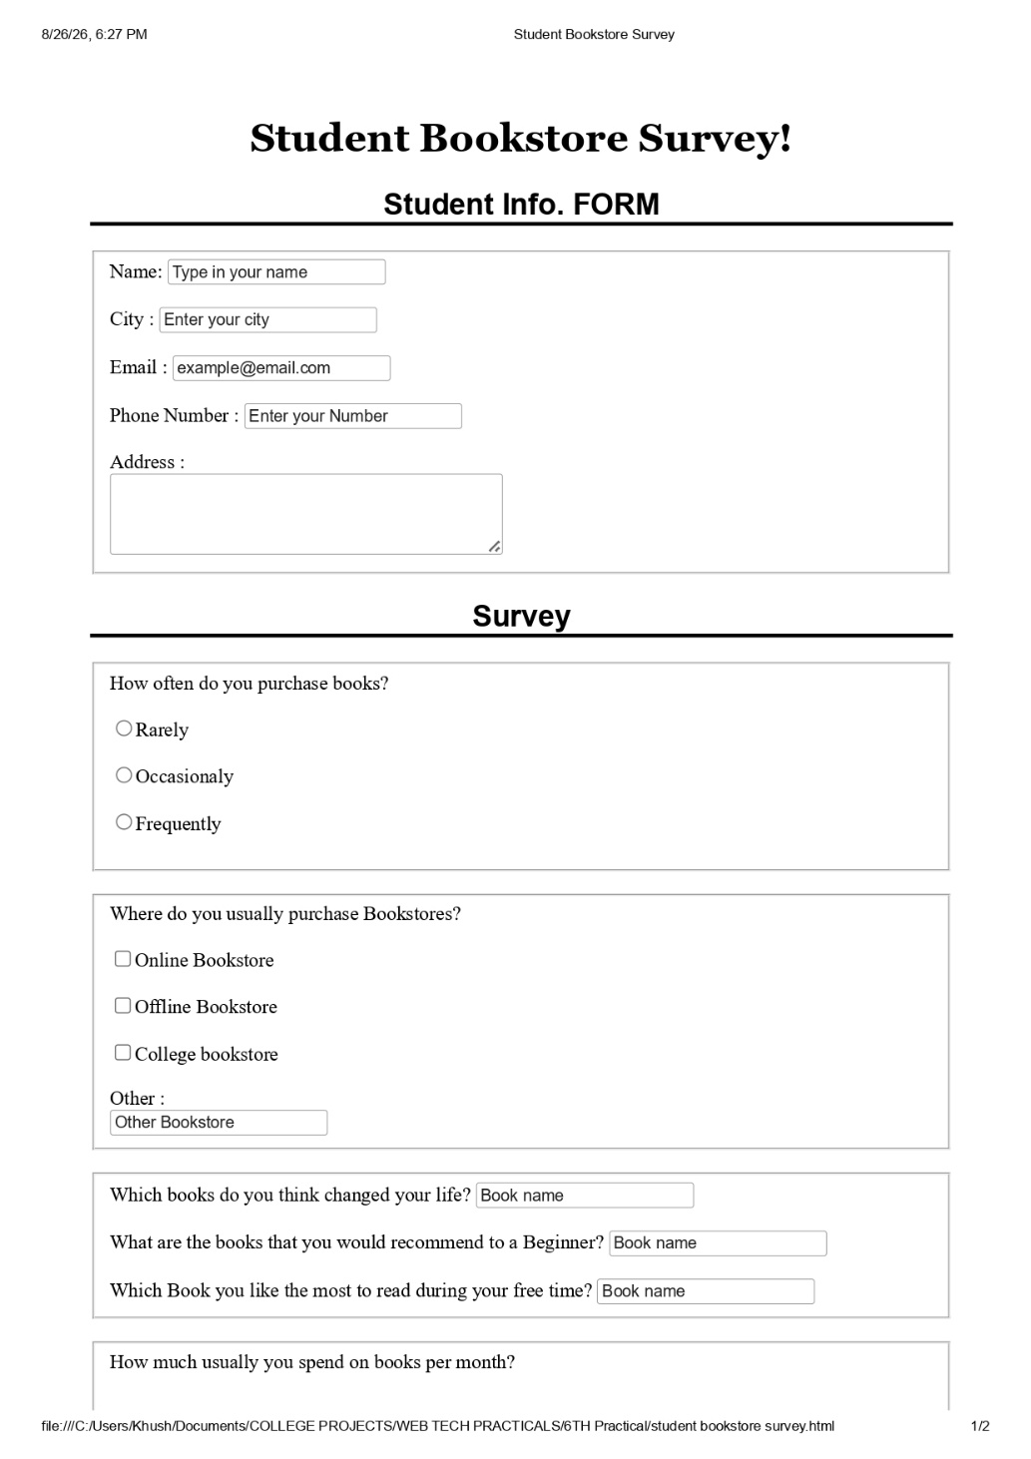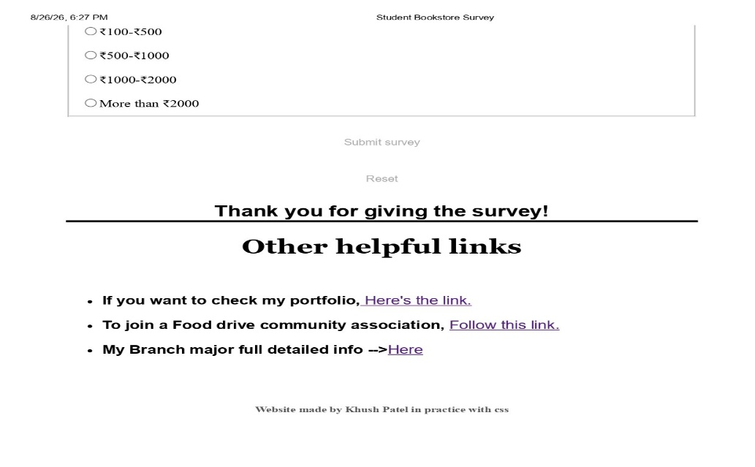
NAME : Khush Patel Branch : Btech Cse core Enrollment no. : 26UGC0255

